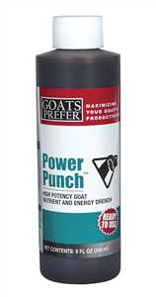
Products enclosed in your New Baby Packet
Goats Prefer Power Punch Supplement (Dark, Molasses colored liquid)
(Vets Plus, Inc) Carefully formulated to help support normal energy levels, appetite and digestion. Administer to goats when kidding, weaning, vaccinating, handling, weather changes, shipping or post antibiotic treatment. Give 1 oz per 100 lbs body weight. Works best to just put 1 or 2cc’s into a syringe & squirt it into the goats mouth.

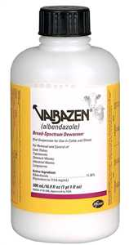
Valbazen Drench Dewormer (Thin watery white liquid)
(Pfizer Animal Health) 11.36% Albendazole for removal and control of liver flukes, tapeworms, stomach worms (including 4th stage inhibited larvae of Ostertagia), intestinal worms and lungworms in cattle and sheep. For treatment of adult liver flukes in nonlactating goats. Do not use in the first 45 days of pregnancy. We use the dosage of 1cc per 10 lbs of bodyweight. (Babies are usually given about 2cc’s) Our adults get 6-8cc’s.

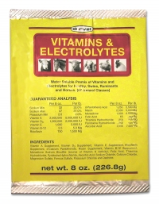
Durvet Vitamins & Electrolytes Powder (Diluted yellow color)
A water soluble premix of vitamins and electrolytes specifically formulated as a water or feed additive; for use when animals are subject to conditions of stress. We put a big “pinch” of this into about ¼ cup warm water, then use a syringe to squirt the electrolytes into the goats mouth. Most of our goats absolutely LOVE this stuff, and look forward to getting it. We use it before, during, & after shows – and/or for any stressful event or illness.

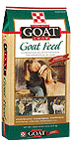
Purina Goat Chow (Great all-around grain)
Purina Goat Chow is fortified with all the essential vitamins and minerals, such as selenium, Vitamin E, and cobalt and provides 16% all natural protein. Goat Chow can be fed to dry does, growing does, bucks, Pygmy goats, Show goats and as a milking ration. We recommend adding Ammonium Chloride to a buck/wethers grain, a small pinch at each grain feeding to prevent Urinary Stones.
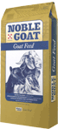
Purina Noble Goat Grower 16% or 20% (Good grain for growing goats)
Noble Goat™ Grower 16 (or 20) is a pelleted complete feed formulated for the optimum growth, development and maintenance of goats. Noble Goat™ products deliver the nutrition and performance you expect.

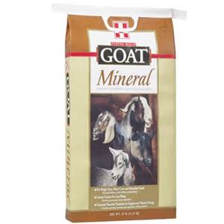
Purina Goat Mineral (Great all-around goat mineral)
All-purpose vitamin and mineral supplement suitable for goats of all ages and breeds. Feed free-choice from sheltered feeders or mix into finished rations to provide approximately 1/4 to 1/2 ounce per head daily.

