2015 Breeding Chart, Updated 4/1/2015

DOE | BUCK/BREEDING INFO | DUE DATE | price
Camanna WR Moonlight Serenity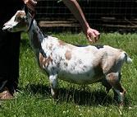  2013 LA: VEEV 87 | 2015 - Serenity x Bachelor Party  Standing heat on 9/17/2014 – possibly due 2/9/2015  (in pen from 9/17-9/21)-10/30,  possible heat on 10/10/2014 – possibly due 3/4/2015  Ultrasound @ OSU on 11/19 confirmed twins+ at about 30-35 days along...which means she should be due about 3/5/2015 | Kidded w/single doe, retained | 0
Poppy Patch PB Peggy Sue  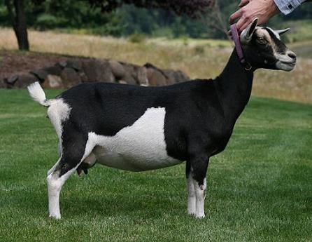  2013 LA: VEEV89 | Bred to Bachelor Party (Escaped!) Peggy x BP kids pedigree  Escape w/Bachelor Party 12/11/14,  Noticed her in heat 1/2/15 - OSU Ultrasound on 2/12/2015 showed I believe her typical 3 kids atleast, but they didn’t look old enough for the Dec.11th date so she must’ve got bred on 1/2…grrrr….would make her due around 5/25-6/5??  BioPryn results from 1/29/15 - PREGO |  | 1 doeling retained  1 buckling retained  Does: $450  Bucks: $450
Surfer Girl  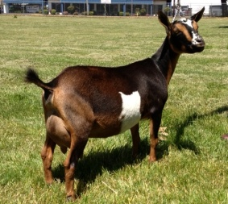  VVVV 87 (as a 1st Freshener) | In w/Buck Rogers 12/7/14, no heat, Possibly bred 12/11/14,  BioPryn results from 1/29/2015 – Open  Standing heat, 1/10/15, bred to B.Rogers, due 6/4/15  Standing heat, 1/31/15, bred to B.Rogers, due 6/25/15  BioPryn results from 2/25/15 - Open  Will try to breed her again in April to Castle Rock Glam Slam, pedigree here |  | 1 doeling retained  1 buckling retained  Does: $550  Bucks: $550
Macy Marie  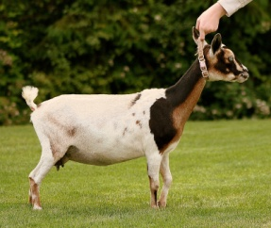  2013 LA: +EE+85 Blue Eyes | 2015 Macy x Bachelor Party  Bred on 11/22/2014 – would be due 4/16/2015  Bred on 12/30/2014 (in for a few days) – would be due around 5/24/2015  BioPryn results from 1/15/2015 – PREGO  Ultrasound on 2/5/15 show twins+ |  | 1 doeling may be retained  Does: $450  Bucks: $450  Blue Eyes possible
Bellafire DC Midnight Melody  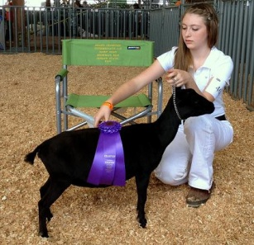  not appraised yet - Blue eyes | 2015 Bred to Castle Rock GN Gran Torino, kids pedigree here  Bred on 12/7-12/8/2014 – possibly due 5/1/2015  Standing heat, bred on 12/11/2014 – possibly due 5/5/2015  BioPryn results from 1/15/15 – PREGO  Ultrasound on 2/5/15 show twins + |  | 1 doeling may be retained  Does: $450  Bucks: $450  Blue Eyes possible
Bellafire DC Sweet Alyssum  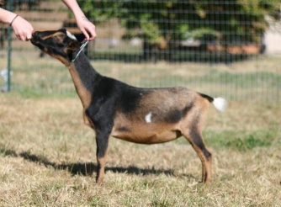  2014 LA: VEEV88 (1st Freshener) | 2015 Bred to Castle Rock Gran Torino 12/7-12/8, no heat?  BioPryn results from 1/29/2015 = OPEN  Bred to Bellafire GT Monte Carlo early Feb,  BioPryn results from 2/25/15 = PREGO  Due sometime between June 15th – 30th |  | 1 doeling may be retained  Does: $450  Bucks: $450
Algedi Farm DJ Cadenza  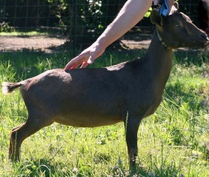  2014 LA: VEEV87 (1st Freshener) | 2015 Bred to Bachelor Party , kids pedigree here  Bred to BP, 12/31/14-1/1/15, due 5/25/15  BioPryn results from 1/29/2015 - PREGO |  | 1 doeling retained  1 buckling retained  Does: $550  Bucks: $550
Bellafire DC Beach Bunny  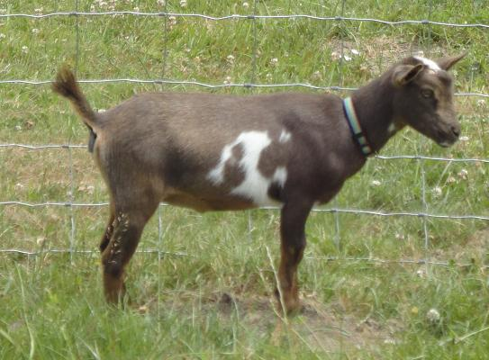 | 2015: Bunny x Bachelor Party  Bred on 12/30/2014 – would be due 5/24/2015  BioPryn results from 1/29/2015 - PREGO |  | Does: $350  Bucks: $350  Wethers: $100ea or 2/$150
Bellafire CB Macy's Milky Way  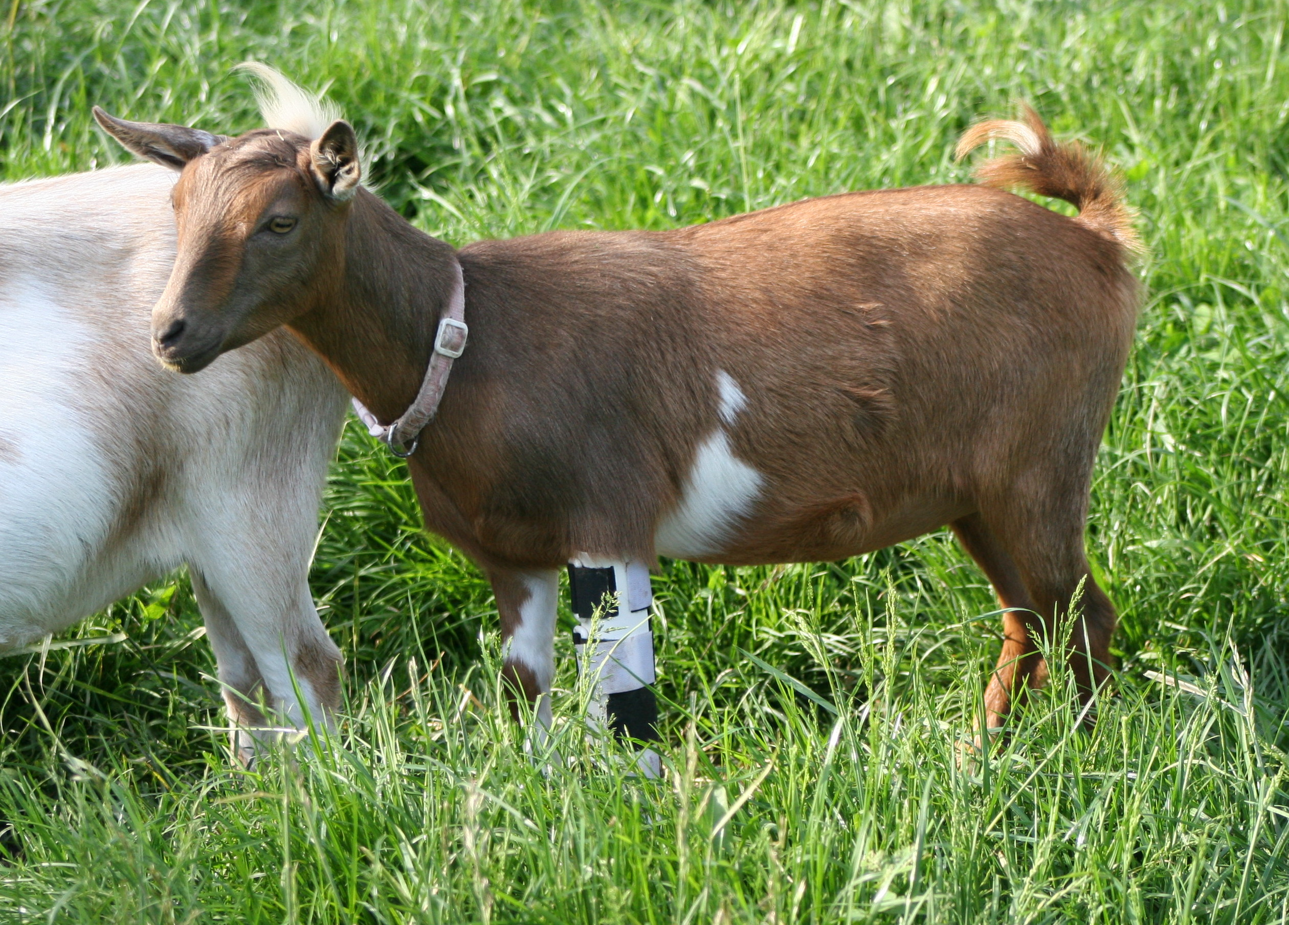  not appraised yet – had broken leg | 2015: MiMi x Algedi Farm Buck Rogers  Standing heat, bred 11/19/14, due 4/13/15  Standing heat, bred 12/7-12/8/14, due 5/1/15  BioPryn results from 1/15/2015 – PREGO  Ultrasound 2/5/15 shows TRIPLETS for this little first freshener! WooHoo!! |  | Does: $350  Bucks: $350  Wethers: $100ea or 2/$150
Bellafire HH Patty Cake  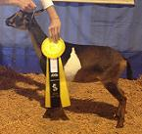  Has 1 Jr. CH. w/ ADGA | 2015:  Patty x Buck Rogers – bred on 1/8/15 to B.Rogers  BioPryn results from 1/29/2015 – Open  Bred to Bellafire BR Apollo on 2/8/15  BioPryn results from 2/25/15 = Open  Will try to breed here again in April to Castle Rock Glam Slam, pedigree here |  | Does: $350  Bucks: $350  Wethers: $100ea or 2/$150
Bellafire BP Flower Girl  Has 1 Jr. CH. w/ ADGA | Bred to Bellafire GT Monte Carlo  Standing heat, bred 2/1/2015, due 6/26/2015  Open, L:2/11/2015  Flower Girl x Monte kids pedigree here  OR  Flower Girl x Castle Rock Glam Slam, kids pedigree here |  | Does: $350  Bucks: $350  Wethers: $100ea or 2/$150

